**Neighborhood Property Value Analysis**

# Introduction

The South St. Petersburg Community Redevelopment Area (CRA), which was founded in 2015, set out to revitalize the City of St. Petersburg. This project's main goal is to evaluate the effects of the CRA by looking at past trends in property values after its creation. There are two years of data available, 2015 and 2022. With this data, we seek to identify property value changes based on neighborhoods and property type, as well as identify high value neighborhoods and growth rates to better inform strategic decisions by the city of St.  
Pete for redevelopment investments through direct analysis results and interactive visualizations made using Tableau public.

**Research Question for project:**

How have taxable property values changed in specific neighborhoods within the South St. Petersburg Community Redevelopment Area from 2015 to 2022, and what factors, such as property type and homesteading status, have influenced these changes, guiding future investment and development strategies in the city.

We will be focusing specifically on 4 categories, namely:

1. All Properties
2. Strictly Residential Properties
3. Single Family Residential Properties and the ones which are not homesteaded.
4. Single Family Residential Properties and missing middle properties.

# Methodology

**Description of Dataset:**

The dataset is a comprehensive compilation of property-related information within the South St. Petersburg Community Redevelopment Area (CRA). We have data for 2 years i.e., 2015 and 2022. It encompasses a range of vital data, which is essential for assessing property values, understanding property usage, and discerning geographic distribution, all of which are pivotal in shaping future investment and development strategies within the city.

***Methodologies Used:***

After reviewing the dataset and project requirements, we spent some time analyzing the quality of data and ideating interesting ways to highlight comparisons in property values. To that end, we took the following steps:

**Data Preparation:**

* Utilized Python to merge two distinct data files containing data of 2015 and 2022. and conducted a thorough data cleansing operation, identifying duplicate values resulting in a final dataset with 29,455 unique required entries.
* Incorporated latitude and longitude coordinates for each neighborhood. This step proved necessary to facilitate the creation of geographic visualizations, particularly maps, which play a pivotal role in our analysis as it is more user friendly to visualize.
* Added 3 categories for different property uses and created calculated fields for Mean and Median values. By standardizing and refining our data in this manner, we ensured the dataset's integrity and enhanced its utility for our project's objectives.

**Data Visualizations:**

Using Tableau, we crafted a range of informative visualizations including interactive maps, line graphs, and dynamic charts highlighting property value trends from 2015 to 2022 in specific South St. Petersburg neighborhoods. These visual representations allow for a clear understanding of property value changes over time and facilitate comparisons between different areas. Furthermore, we created visualizations illustrating the distribution of properties, providing geographic context and insights into the spatial distribution of various property types, including residential and commercial. These dynamic visualizations serve as a key component of our project, aiding in the presentation and interpretation of complex property data for informed decision-making by the City of St. Petersburg.

# Results

**St Petersburg Neighborhood Property Value Analysis (All Properties) - 2015 vs 2022**

In 2015, property values in St. Petersburg's neighborhoods varied significantly. **Woodlawn Oaks** had the highest average property value at around **$979,495** USD, followed by Historic Kenwood and east of Palmetto Park and Perry Bayview. In Historic Kenwood, the presence of retail and residential properties contributes to its higher property value. On the opposite end of the spectrum, **the Historic Gas Plant District** had low property values due to its vacant **3.8 acres of vacant park land** (or lack of data). Although they have residential properties, other neighborhoods like Thirteenth Heights and Mel Tan Heights also have notably low property values, with the median lying around $16,751 USD and $17,430 USD, respectively. This contrast illustrates how land use plays a vital role in determining property values.

**Note**: Jordan Park Resident Management median value is zero because there is only one property with *taxable property value. Hence it is considered as an outlier.*

In 2022, property values in St. Petersburg's neighborhoods have changed significantly. **Historic Kenwood** had the highest average property value at around **$654,4340,** up from **$240,769** in 2015. Also, south of Historic Kenwood had a significant growth compared to East of Palmetto Park this year. While the **Historic Gas Plant District** still has low property values due to its **vacant park land**. “North of Lakewood estate” consists of vacant city government and garages covering three-quarters of the total land. Mel-Tan Heights remains at the bottom list with no major change but interestingly Thirteenth Heights has had a growth in the property value in 2022.

**Note**: Data for Woodlawn Oaks was missing for 2022 and therefore has not been mentioned.

***Visualization Description****:* Map visualization representing mean and median of property values in 2015. You can use the property Type parameter to choose between Strictly Residential, Single-family residential and so on as well as an added Homestead filter can be used to see homesteaded status. The bigger and darker the dot, the higher the property value.

When considering residential properties for 2015, out of 31, 28 neighborhoods are classified strictly residential. Historic Kenwood, East of Perry Bayview and Palmetto Park are top on the list with most residential properties also with highest property value. Whereas the residential property value is significantly less in Campbell Park and South of Palmetto Park. It is remarkably interesting to find that comparing different sides (east vs south) of Palmetto Park leads to a wide degree of changes between property value.

Comparing this with residential properties for 2022, our data shows that there are now 27 neighborhoods classified as strictly residential. Historic Kenwood, south of Historic Kenwood and Palmetto Park still lead the list with the highest property values. Interestingly, compared to 2015, the residential value of Campbell Park has improved significantly while this is less so in South of Palmetto Park, pointing to slow growth.

**Which neighborhoods had the most growth in property values from 2015 to 2022? What were the growth rates?**

1. **For all properties**

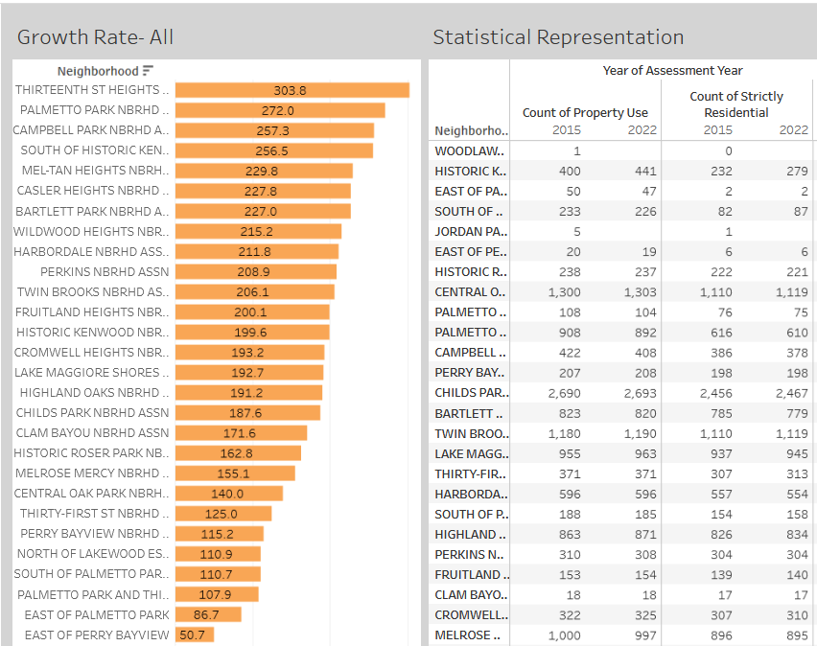

We can see that Thirteen St Heights Neighborhood stands out with an impressive growth rate of 303.8 percent. In contrast, East of Perry Bay View exhibits a lowest growth rate of 50.7 percent. Meanwhile, the Historic Gas Plant District, Woodlawn Oaks and Jordan Park Resident has no property counts in 2022 hence there is no growth rate. An intriguing aspect of this analysis is the relationship between property counts and growth rates. In several neighborhoods, property counts have remained stable from 2015 to 2022, yet there are notable increases in growth rates. A prime example of this phenomenon can be observed in Harbordale and Clam Bayou Neighborhood, where growth rates have surged despite consistent property counts. Another noticeable fact is that even though the property count decreased from 2015 to 2022, Campbell Park still maintains a significant growth rate.

1. ***For Strictly Residential Properties***

The graph provides valuable insights into the growth rates of strictly residential properties across different neighborhoods. Clam Bayou emerges as the leader with the highest growth rate, a remarkable 852.3%, while the neighborhood with the lowest growth rate is Melrose Mercy Neighborhood, registering at 24.3%. It is worth noting that the visualization does not include the Historic Gas Plant District and Woodlawn Oaks, North as it lacks residential properties, which sets it apart from the other neighborhoods in this analysis.

1. ***For Single Family Residency that are not homesteaded***

The graph reveals intriguing trends in the growth rates of single-family properties that are not homesteaded across various neighborhoods. Notably, Clam Bayou boasts the highest growth rate at 272.7%, while the lowest growth rate is observed in East of Perry Bayview, standing at 50.9%. Surprisingly, in several neighborhoods, the counts of single-family residential properties not homesteaded have exhibited slight change from 2015 to 2022. However, there are remarkable increases in growth rates, exemplified by neighborhoods like Clam Bayou and East of Palmetto Park. An interesting observation emerges from Palmetto Park, where despite a decrease in the count of single-family residential properties not homesteaded from 285 to 274, the growth rate remains notably high at 217%. Additionally, Thirteenth St Heights experiences both an increase in property count and a significantly elevated growth rate, highlighting the dynamic nature of property values and demand in these areas.

1. **A. For all single-family residential properties only and B. For single-family residential properties and missing middle properties:** Please see the visualizations in the Appendix, even in these cases, the same trend follows where there is increase in growth rate irrespective of increase in the property counts for most of the neighborhoods.

# Conclusions

In 2015, property values in South St. Petersburg's neighborhoods exhibited considerable variation, influenced by factors such as land use, property type, and geographic location. The Historic Kenwood neighborhood had the highest average property value, emphasizing its attractiveness for residential purposes.

The year 2022 witnessed significant changes in property values. Historic Kenwood maintained its status as a high-value neighborhood, but other areas like the South of Historic Kenwood experienced substantial growth. Notably, the Historic Gas Plant District remained at the bottom with low property values due to its vacant park land.

Thirteenth St Heights Neighborhood emerged as the standout performer with the highest growth rate of 303.8%, indicating a significant increase in property values over the seven-year period.

East of Perry Bay View displayed the lowest growth rate at 50.7%, signaling a decline in property values in this neighborhood.

Interestingly, several neighborhoods with stable property counts experienced notable growth rates, underscoring the complexity of factors affecting property values.

**Opportunities for Further Analysis:**

Exploring the factors contributing to property value changes in specific neighborhoods, such as policy changes or infrastructure improvements and Identifying areas with the most potential for future property value growth and formulating strategies to support this growth.

# Link to Visualizations

All visualizations can be accessed [here.](https://public.tableau.com/app/profile/vinaya.nayak/vizzes)